blackCSIS210 - Data Structures

Web App. Dev.

Laboratory 10

Lab 1

Names _____________________________________________________

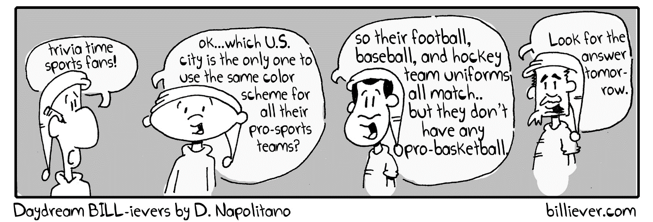

General Lab Procedures

- You should create a directory (folder) in your home account called csis390. At the beginning of each lab, create a new sub-directory called labX, where X is the lab number.
- Files used in the lab can be found on the course canvas webpages.
- Turn in this lab sheet stapled to print outs of the code you produce as needed in each assigned section from the laboratory manual. These sheets should be in order. One lab submission is sufficient for each group.
- You can find documentation for the HTML 5 specification, the CSS, the Javascript, and php references respectively at
https://html.spec.whatwg.org/
https://developer.mozilla.org/en-US/docs/Web/CSS/Reference
https://developer.mozilla.org/en-US/docs/Web/JavaScript
https://www.php.net/manual/en/langref.php

Lab Objectives
- Practice using php
- Create and manage a table using SQL and MySQL

Lab 10

Part 1 – Processing a full page of questions

In this part of the lab, you will continue your work from lab 9, regarding a trivia application. You will now be processing a page with multiple questions.
- Create a php file called process_game.php, which will process a series of questions from a form.
  - Since the form will POST answers, you will need the questions for each answer. Transfer the question text via SESSION variables.
  - Use an SQL Select query to get each answer from the table, to verify the user’s response.
- Your file should update the correct/incorrect information. This can be done in one of two ways, depending on your previous database design.
  - If you do not have a separate Game table, you will need to update fields from the User table. An update query looks like this:
UPDATE table_name
SET column1 = value1, column2 = value2, ...
WHERE condition;
In this case, the condition would be the username of the user. This information can also be obtained by a previously set SESSION variable.
  - If you do have a separate Game table, then you will need to Insert another row into that table with the username, the correct number of answers and the incorrect number of answers.
- Once completed, demonstrate your webpage for your instructor and have him initial here. If you do not finish during the lab period, then demonstrate your webpage at the beginning of the next lab period.

Instructor’s Initials ________

Part 2 – Showing the results

In this part of the lab, you will show the correct/incorrect statistics for each player in the Users table.
- Again, this is done depending on your database design.
- Create a new file called show_results.php.
- If you do not have a separate Game table,
  - All the information is in the Users table, and can be directly queried using a SELECT * from UsersXXXXX SQL query.
- If you do have a separate Game table,
  - You will have to aggregate the information from the table.
  - For each user in the Users table,
    - Find rows in the Game table that match with the same username, and aggregate the total correct and incorrect values.
    - Print out a row of statistics, once accumulation is complete for a user.
- Once completed, demonstrate your webpage for your instructor and have him initial here. If you do not finish during the lab period, then demonstrate your webpage at the beginning of the next lab period.

Instructor’s Initials ________

Part 3 – Player Login Page

In this part of the lab, you will create a login page for players. This will verify that the user is in the database. Once successful, a list of options will be displayed.

- Create a login page called login.php.
- Create a login/password form for logging into your application using php.
  - Have echo statements create this form.
  - Make it look nice with appropriate CSS.
- Have the form recursively process itself.
- If login is in the database and the password matches, then display a list of options for the player.
  - At this point, you can set a SESSION variable equal to the username. This will help, as noted above, with updating correct/incorrect information.
  - There will be two option hyperlinks.
    - Playing a game. This will take you to your get_game.php script.
    - Showing the statistics. This will take you to your show_results.php script.
    - Add return links to make_game.php and show_results.php to return to the login page (and to the options link menu).
- Once completed, demonstrate your webpage for your instructor and have him initial here. If you do not finish during the lab period, then demonstrate your webpage at the beginning of the next lab period.

Instructor’s Initials ________

Part 4 – Administration page

In this part of the lab, you will create an administration page for organizing the scripts needed to set up our trivia game application.

- Create a new php script called admin.php.
- This script should create a page with menu hyperlink options for the following functionalities:
  - Creating a User
  - Showing all Users in the Users table
  - Creating a Question
  - Showing all Questions in the questions table
- (5 points extra credit)
  - Add functionality and options to delete a question from the questions table.
- (5 points extra credit)
  - Add functionality and options to delete a user from the users table.
- Add appropriate CSS to make this look nice.
- Once completed, demonstrate your webpage for your instructor and have him initial here. If you do not finish during the lab period, then demonstrate your webpage at the beginning of the next lab period.

Instructor’s Initials ________

- No formal canvas submission needed. Grade will be based upon participation and the files uploaded to the servers. Your HW#3 grade will be based upon the server code, so each person/group will need to inform me via email where to find this code and a valid username/password to test your software.

