SIENA COLLEGE
27th Annual High School Programming Contest

April 4, 2014

Problem #1: SUMS AWAY
Background Information:
The sum of the first N counting numbers is N (N + 1) / 2.
The sum of the first N perfect squares is N (N + 1) (2N + 1) / 6.
The sum of the first N perfect cubes is (N (N + 1) / 2)².
SUPERSUM (N) is defined to be the sum of the sum of the first N counting numbers, perfect squares and perfect cubes.
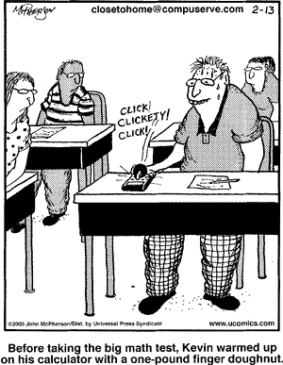

Programming Problem:
Input: a positive integer N less than 200
Output: The SUPERSUM (N)

Example 1: Input: 5

Output: 295

Example 2: Input: 6

Output: 553

