SIENA COLLEGE
27th Annual High School Programming Contest

April 4, 2014

Problem #2: TIME IS?
Background Information:
If you were asked to “simplify” 200 seconds you would not say, ” 3.3333333” minutes. You would say, “3 minutes and 20 seconds”.
If you were asked to “simplify” 1000000 (one million seconds) you would say, “11 days, 13 hours, 46 minutes, and 40 seconds”.
And if you were asked to “simplify” 1000000000 (one billion seconds) you would say, “31 years, 259 days, 1 hour, 46 minutes, and 40 seconds”. Once we are asked to simplify a number of seconds greater than 31536000 we will assume that a year is exactly 365 days long.
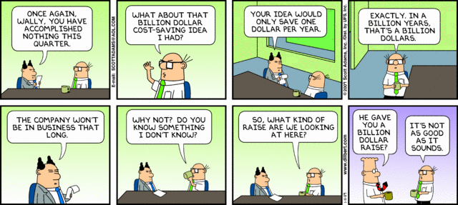

Programming Problem:
Input: a positive integer N less than 2000000000 representing a number of seconds.
Output: N seconds “simplified” into years, days, hours, minutes, and seconds. You must
only output the units starting with the greatest unit that has a value greater
than 0.

Example 1: Input: 3640

Output: 1 hours

0 minutes
40 seconds

Example 2: Input: 1000000000

Output: 31 years
259 days
1 hours
46 minutes
40 seconds

