SIENA COLLEGE
27th Annual High School Programming Contest

April 4, 2014

Problem #3: PYTHAGOREAN DAYS
Background Information:
A Pythagorean triple consists of three positive integers a, b, and c such that a² + b² = c². A right triangle whose sides form a Pythagorean triple is called a Pythagorean triangle. Another way to describe a Pythagorean triangle is a triangle with a 90 degree angle with all sides being integers. May 12, 2013 was a Pythagorean Day because we write the date as 5-12-13 and (5, 12, 13) is a Pythagorean triple. Note that we designate the year using only the last two digits. Also note that the year for a Pythagorean day is always the hypotenuse of the corresponding right triangle.

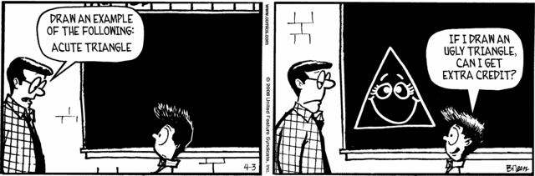

Programming Problem:
Input: M and N (one input value per line), two years in the 21st century. Note: The year 2000 is
not in the 21st century and the year 2100 is.
Output: The number of Pythagorean days in the given range (inclusive) followed by the
dates in chronological order.

Example 1: Input: 2002
2014

Output: 6
3-4-5
4-3-5
6-8-10
8-6-10
5-12-13
12-5-13

