SIENA COLLEGE
27th Annual High School Programming Contest

April 4, 2014

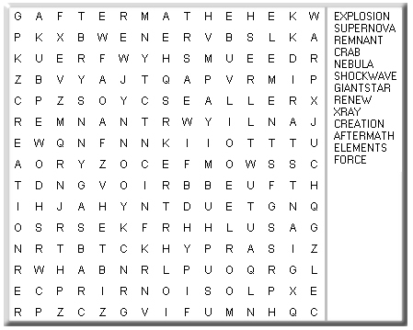
Problem #6: WORD SEARCH
Background Information: The classic word search problem is one where a person tries to locate a word hidden in a grid of letters (no wrap-arounds). The word may appear forwards or backwards, and either vertically, horizontally or diagonally. This problem asks you to find how many times a word is found in the grid. A word could appear 0 or more times in the grid. The grid will be a square grid (same number of rows and columns) of letters (all in uppercase). The number of rows/columns will be at least 3 and at most 10. The list of words (at least 1 and at most 20) to be found will follow (also in uppercase).

Programming Problem:
Input: The number N, followed by N strings of N characters each. The number W, followed by W strings.
Output: W lines of output, where each line has a word list string followed by a colon (:) and then the number of times it was found in the grid. The output is in the same order as the wordlist input.

Example 1: Input: 3
BOB
AAA
BOB
2
BOB
BAB

Output: BOB:2
BAB:4

Example 2: Input: 5
ABABA
BABBA
ABABA
BBABB
ABABA
4
AA
BBA
BBABA
AAABBB

Output: AA:8
BBA:6
BBABA:0
AAABBB:0

