### **SIENA COLLEGE**

**30th Annual** High School Programming Contest

##### **March 24, 2017**

###### Gold Problem #1:  2017 is Prime and 2017 has an Iterative Collatz Value of 68

Background Information:  Eighty years ago, in 1937, the German mathematician, Lothar Collatz, posed a conjecture that has become known as the Collatz Conjecture and is sometimes called the 3N + 1 conjecture. Collatz said that that if you start with any positive integer N and divide it by 2 to get a new value for N if it is even or triple it and add 1 to get a new value for N if it is odd and continue doing this then you will eventually get to 1. Many great mathematicians have worked on this problem and none have been able to prove the conjecture or find a counter example. 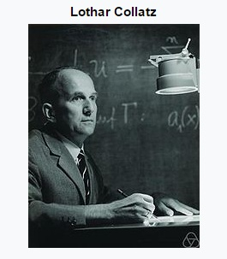

Example: if you start with N = 7 then

7 → 22 → 11 → 34 → 17 → 52 → 26 → 13 → 40 → 20 → 10 → 5 → 16 → 8 → 4 → 2 → 1 .

Note that it takes 16 steps for 7 to reach 1. We say that 7 has an Iterative Collatz Value or ICV of 16.

The integer 2017 has an ICV of 68.

For values less than a billion, the one with the largest ICV is 670,617, 279 which has an ICV of 986.

###### Programming Problem:

Input:  A positive integer N ≤ 100,000.

Output: The number N followed by a space followed by the ICV(N).

###### Example 1: Input:  2017

###### Output:  2017 68

###### Example 2: Input:  7

###### Output:  7 16

V1