### **SIENA COLLEGE**

**30th Annual** High School Programming Contest

##### **March 24, 2017**

###### Green Problem #1:  A Multiplication Treat

Background Information: Hopefully you enjoyed this treat when you were in middle school. Pick your favorite three digit number N that is greater than 100. Your number N must be a positive integer. Multiply N by 13 to get the product A. Multiply A by 11 to get the product B. Multiply B by 7 to get the product C. What is interesting about C?

###### Programming Problem:

Input:  A positive integer N with 100 < N < 1000.

Output: On four consecutive lines: N, A, B, and C.

###### Example : Input:  123

###### Output:  123

1599

17589

123123

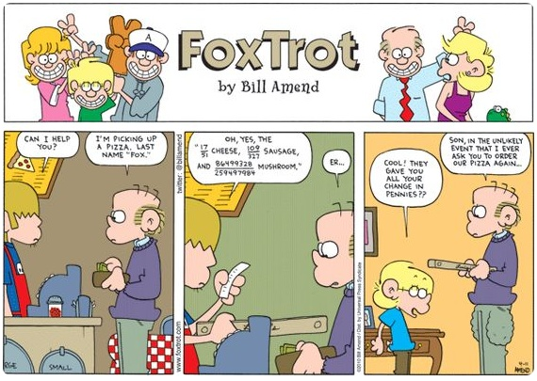

During the contest, Siena assistants will notify you when it is time to take a short break and get some pizza.

V1