### **SIENA COLLEGE**

**30th Annual** High School Programming Contest

##### **March 24, 2017**

###### Green Problem #2:  Do You Know Your Phone?

Background Information:  There were several different key pads used on phones of the past. Image 1, below, shows one of them.

 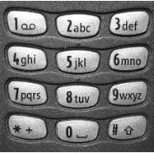

Image 1 Image 2

Fortunately, there is an international telephone recommendation (ITU E.161) for placing letters on the phone key. Most phones manufactured today use this standard. Image 2, above, shows the recommendation. You may notice that the new standard includes the letters “q” and “z”. These were added when text messaging became available.

###### Programming Problem:

Input:  A lower case letter.

Output: The letter followed by a space followed by the corresponding number on the

recommended keypad.

###### Example 1: Input:  r

###### Output:  r 7

###### Example 2: Input:  z

###### Output:  z 9

V1