Siena College’s 31st Annual High School Programming Contest

Sponsored by Transfinder

April 13, 2018

Green Problem #1: Go Forth and Compute the FOURTHSUM
Background Information:
The sum of the first N counting numbers or 1 + 2 + 3 +… + N is N (N + 1) / 2.
The sum of the first N perfect squares or 1² + 2² + 3² + … + N² is N (N + 1) (2N + 1) / 6.
The sum of the first N perfect cubes or 1³ + 2³ + 3³ + … + N³ is (N (N + 1) / 2)².

The sum of the first N perfect fourths or 1⁴ + 2⁴ + 3⁴ + … + N⁴ is N (N + 1) (2N + 1) (3N² + 3N - 1 ) / 30
For example, 1⁴ + 2⁴ + 3⁴ + 4⁴ + 5⁴ is 5 *(5 + 1) (2*5 + 1) (3*5² + 3*5 - 1 ) / 30 = 979
FOURTHSUM (N) is defined to be the sum of the first N perfect fourths.
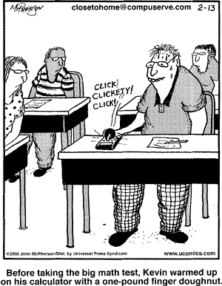

Programming Problem:
Input: a positive integer N less than 51
Output: The FOURTHSUM (N)

Example 1: Input: 5

Output: 979

Example 2: Input: 50

Output: 65666665

