Siena College’s 31st Annual High School Programming Contest

Sponsored by Transfinder

April 13, 2018

Green Problem #7: game, SET, and match

Background Information: The game of Set consists of 81 unique cards. Each card has four characteristics: count, shape, texture, and color. Each characteristic has three different values: count (1, 2, or 3), shape (Diamond, Peanut, Oval), texture (Hollow, Lines, Solid), and color (Green, Violet, and Red).

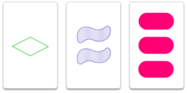
Each card has a textual representation based upon the values of the characteristics in the order: count, shape, texture, color. For example, the three pictured cards to the left have the following text strings respectively: 1DHG, 2PLV, and 3OSR.
The shape characteristics of Diamond, Peanut and Oval are abbreviated as D, P and O respectively.
Textures are abbreviated as H, L, and S. Colors are G, V, and R.

A set is formed by three cards when each of the card’s characteristics, looked at one-by-one, are the same on each card, or, are different on each card. All of the characteristics must separately satisfy this rule. In other words: shape must be either the same on the three cards, or different on each of the three cards. The same for count, texture, and color.

Consider the twelve cards in Panel-1 below.

Panel-1 Panel-2
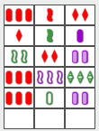
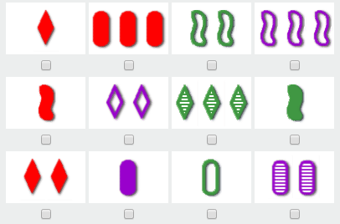

Six sets of three cards can be found in these twelve cards. Five of the sets are shown in Panel-2.

The top three cards are a set because the count is different for all three cards, the shape is different for all three cards, the texture is the same for all three cards, and the color is the same for all three cards.

The second row of cards is a set because the count is the same for all three, the shape is different for all three, the texture is the same for all three, and the color is different for all three.

Can you find the sixth set that is not listed? Continue to the next page to confirm your answer.

The sixth set is:

The textual representation for these three cards of the sixth set are:1DSR, 2DHV, and 3DLG.

Programming Problem:
Input: An integer N, with 3 ≤ N ≤ 12, followed by the textual representation of N set cards, one card per input line.

Output: The textual representation of all sets of three cards found in the N cards. Each set of three cards is to be output on a separate line. The three cards on a line must be in lexicographic order and the output lines must also be in lexicographic order. It there are no sets a NO SETS message is output. Note, in mathematics, lexicographic order is a generalization of the ways words are alphabetically ordered based on their component characters.

Example 1: Input:

4

1OHG

1DLG

2OSR

2DLG

Output
NO SETS

Example 2: Input:

12

1DSR

3OSR

2PHG

3PHV

1PSR

2DHV

3DLG

1PSG

2DSR

1OSV

1OHG

2OLV

Output

1DSR 1OSV 1PSG

1DSR 2DHV 3DLG

1OHG 2OLV 3OSR

1PSR 2DSR 3OSR

2DSR 2OLV 2PHG

3DLG 3OSR 3PHV

Note that example 2 corresponds to the diagrams on the previous page.

