**Siena College’s 33rd Annual** **High School Programming Contest**

**Sponsored by Transfinder**

**June 2, 2021**

###### **Gold Problem #7:  Tower of Unit Fractions**

###### **Background Information:**

The Tower of Unit Fractions starts with the top row (row =1) and every row begins and ends with the reciprocal of the row number.  The index number corresponds to the position in the row with the leftmost fraction having index =1, and the rightmost having index equal to the row number. Each number in row K is the sum of the two numbers in row K + 1 beneath it.  For example, 1/12 is equal to the sum of 1/20 and 1/30.

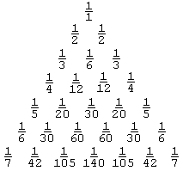

Your program will be given a legal row number (starting with 1) and a legal index number (also starting with 1) in the Tower of Unit Fractions, and then print out the fraction in lowest terms from the triangle that is indicated by the input.

Programming Problem:

Input:  K and I where 1 ≤ K, I ≤ 15, and I ≤ K

Output: The Ith fraction in the Kth row of the Tower of Unit Fractions. The numerator is immediately followed by a forward slash, followed by the denominator. No spaces.

Example 1: Input: Example 3: Input:

1 1 4 2

Output:  Output:

1/1 1/12

Example 2: Input: Example 4: Input:

3 3 7 3

Output:  Output:

1/3 1/105