**Siena College’s 33rd Annual** **High School Programming Contest**

**Sponsored by Transfinder**

**June 2, 2021**

###### **Green Problem #7:  Just Filling In**

Background Information:

In this puzzle, you are to use the first 25 letters of the alphabet (A through Y) to fill in a 5 x 5 grid, such that each letter is adjacent (vertically, horizontally, or diagonally) to the previous one.  The letters must also conform to the clues around the grid, which indicate the column, row or diagonal where each letter lies.  Each grid, with the corresponding clues and the starting location of the letter A, has a unique solution.

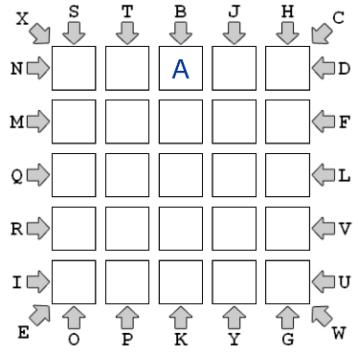                                           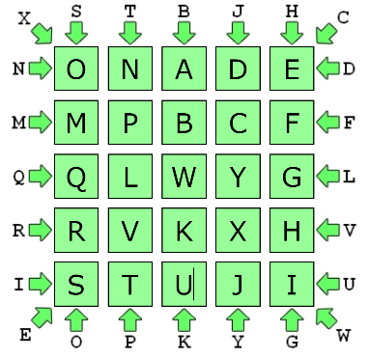

Your program will require seven lines of clue input, which contain the clue letters, as indicated above.  The first and last lines have seven letters, while the second through sixth lines have only two letters.  This is followed by the row and column index of the letter A in the solution with indices starting at 0. The top row is row-0 and the bottom is row-4. The leftmost column is column-0 and the rightmost column is column-4.

Programming Problem:

Input:  Seven lines of input of uppercase letters, as indicated above, followed by 1 line of input indicating the row and column of the letter A.

Output: Five lines of 5 characters, which indicate the solution to the grid.

Example 1: Example 2:

Input: Output: Input: Output:

###### XSTBJHC ONADE BQTFLKS DEFGH

ND MPBCF DG CBAJI

MF QLWYG CJ QPMLK

QL RVKXH PM RTONY

RV STUJI YO SUVWX

IU XU

EOPKYGW HREVWIN

0 2 1 2