### 

**34th Annual High School Programming Contest**

| **Sponsored by** |  |
| --- | --- |

##### April 8, 2022

###### Green Problem #5: Wordle

Background Information: Wordle is a popular word guessing game, in which you attempt to guess a hidden five letter word (called the target) in at most six attempts. Each attempt will result in a colorization of your guess, according to the following scheme: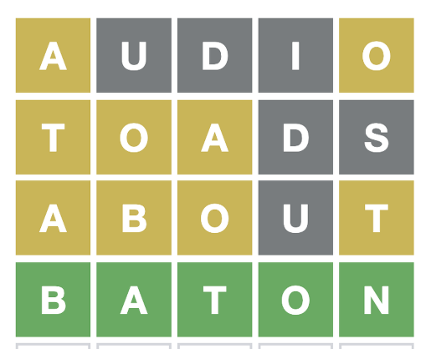

* Letters that are not in the word will turn dark.
* Letters that are in the word and are in the correct spot in the target will turn green.
* Letters that are in the word but are in a different spot will turn yellow. If K ≥ 2 or more letters that are the same in a guess appear in the target T < K times, then only the leftmost T letter(s) will turn yellow; the rest will turn dark. For example, if the target word is IDIOM, and the guess is DADDY, then the coloring of DADDY will be yellow for the first “D”, and then dark for the remaining letters.

Your program will read in a target word (the answer) followed by an integer 1 ≤ N ≤ 6 representing the number of guesses, followed by N guess words. Each word will be exactly 5 uppercase letters.

Your program will then output N strings consisting of the letters G, Y, and D for each guess, based upon the colorization scheme noted above. The letter G represents green, Y represents yellow, and D represents dark.

###### Programming Problem:

Input:  1 5-letter word, followed by an integer N in [1, 6], followed by N 5-letter words, each on separate lines, all in uppercase letters

Output: N 5-letter output strings made up of G’s Y’s and D’s for each of the N guesses in order.

###### Example 1: Input:

###### BATON

###### 4

###### AUDIO

###### TOADS

###### ABOUT

###### BATON

###### 

###### 

###### Output:

###### YDDDY

YYYDD

YYYDY

GGGGG

###### Example 2: Input:

###### ICING

6

ONION

ANION

MIMIC

GOING

COMIC

ABOUT

###### 

###### Output:

DYGDD

DYGDD

DYDYY

DDGGG

YDDYD

DDDDD

Example 3: Input:

MIGHT

6

OTTER

TIGHT

SIGHT

LIGHT

NIGHT

FIGHT

###### Output:

DYDDD

DGGGG

DGGGG

DGGGG

DGGGG

DGGGG