### 

**35th Annual High School Programming Contest**

| **Sponsored by** |  |
| --- | --- |

##### **March 31, 2023**

###### Gold Problem #1: Power to the CS People

Background Information:  The binary number system is the base of all computing systems including hardware architecture which includes memory and the arithmetic/logic unit. At least one Siena CS professor recommends that every computer scientist try to memorize the first 17 powers of 2 starting with 20 = 1 and continuing up to 216 = 65,536. Every person, computer scientists and non-computer scientists should know:

210 1,000 and 220 1,000,000 and 230 1,000,000,000 and 240 1,000,000,000,000. Another way to write this is:

210 a thousand and 220 a million and 230 a billion and 240 a trillion.

Write a program that will output powers of 2 starting with 20 = 1.

Programming Problem:

Input:  A positive integer N ≤ 1,000,000

Output: A list of the powers of 2 that are ≤ N, starting with 20 = 1.

Example : Input: 1000

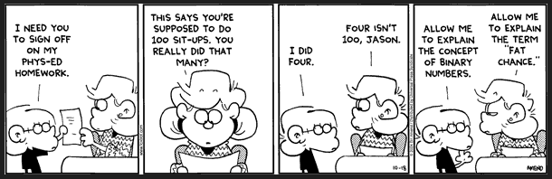

Output: 1

2

4

8

16

32

64

128

256

512