**Siena College’s 35th Annual High School Programming Contest**

| **Sponsored by** |  |
| --- | --- |

##### **March 31, 2023**

###### Gold Problem #6: Transfinder Routing

###### 

Background Information: Our sponsor, Transfinder, specializes in transportation projects. This problem is connected to their bus routing software. Software prototyping is when developers write incomplete versions of a software system that is being developed. This is often done to test out ideas and determine the feasibility of a software project.

You will write a program that is a prototype for a bus routing software project. The program will allow a person to enter commands which will produce a map for a bus route. Two of the commands, F and B, will direct the bus to move Forward or Backward by a given distance in the direction it’s currently facing. Two other commands, R and L, will change the direction the bus is facing by having it turn Right or Left. The bus can be facing East (right), West (left), North (up), or South (down). For your prototype program the grid uses “*” characters to mark the border: 40 *s across the top and bottom; 20 *s down the sides. The bus will begin in the upper left corner of the grid facing East. Your program will track the bus route until the user types a Q (for quit) or the bus cannot fulfill the command because it reaches an “*”. The longest route for the prototype will be of length 52 and it will be marked by the lower and upper-case letters starting with lower-case “a”.

###### Programming Problem:

Input:  A sequence of “legal” moves for bus routing, as described above. Each line will contain one character or one integer. The last line is guaranteed to contain a Q (though you may hit a wall before reaching this instruction).

Output: The grid of *s and spaces that contains the bus route starting with “#” and then using lower-case characters in order followed by upper-case letters in order. The output ends when the input is Q or when the distance that was input takes the bus off the grid. (The route stops BEFORE it overwrites an *.) If a route crosses over itself, the old letter is overwritten by the new letter. (Note: Your output must contain exactly 20 lines of exactly 40 characters each.)

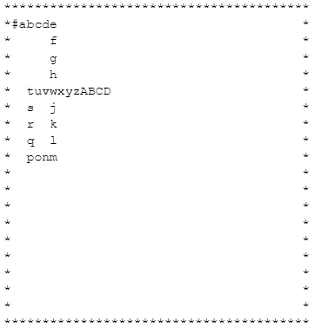

###### Example: Input: F Output:

###### 5

R

F

8

L

B

3

L

F

4

L

B

10

Q