Siena College’s 35th Annual High School Programming Contest
Sponsored by | 

March 31, 2023

Gold Problem #7: Super Peg Game
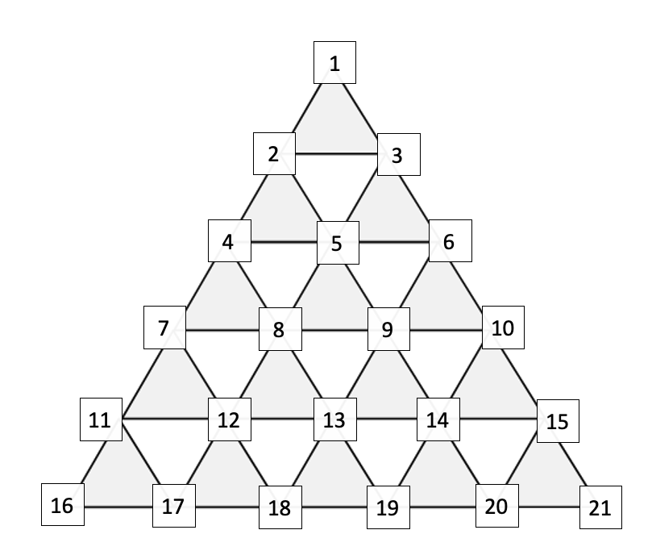
Background Information: The Classic Peg Game is a peg jumping game, in which you attempt to remove pegs from a triangular board via jumping. A peg can jump another if they are consecutive and if there is an empty hole immediately beyond the jumped peg. For example, if pegs were occupying holes 1 and 2 (see diagram for hole numbering) and hole 4 was empty, then a peg could jump from hole 1 to hole 4, resulting in the removal of the peg in hole 2. In the game, if a legal jump can be made, it has to be made. Ultimately, you are aiming for as few pegs on the board as possible with no jumps remaining. However, in Super Peg Game, you have 21 holes (instead of the standard 15) and you are attempting to find the solution to having the MOST number of pegs remaining on the board with no jumps remaining.

A jump is outputted as the beginning peg location, followed by a dash, followed by its landing peg location. Jumps are ordered by their beginning position followed by their ending position. Thus, “1-6” comes before “10-3”, but after “1-4”.
If multiple optimal solutions are possible, the solution outputted will be the one with the smallest opening jump. If a tie occurs, the next jumps in the solutions are checked using the same criteria until the tie is broken.

Programming Problem:
Input: The integer number of pegs in the starting grid N < 21, followed by N distinct holes starting with a peg.
Output: The minimum number of jumps K that would leave a board with no possible jumps, followed by K jumps, each on their own line.

Example : Input: 5 3 6 19 18 13
Output: 2
3-10
18-20

