### 

**35th Annual High School Programming Contest**

| **Sponsored by** |  |
| --- | --- |

##### March 31, 2023

###### Green Problem #1: Rectangle Counting

Background Information:

The number of unique rectangles that can be identified in an 8 by 8 checkerboard is 1,296. There are various ways to enumerate the rectangles. While counting the rectangles in a standard 8 by 8 checkerboard is an interesting problem, even more interesting is counting the number in an N by N checkerboard.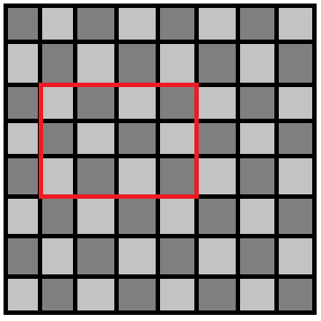

The more general problem may be approached inductively as follows:

There is 1 rectangle in a 1 by 1 checkerboard.

There are 9 rectangles in a 2 by 2 checkerboard.

There are 36 rectangles in a 3 by 3 checkerboard.

There are 100 rectangles in a 4 by 4 checkerboard.

You may notice that 1 = (1 x 2 / 2)2

and 9 = (2 x 3 / 2)2 

and 36 = (3 x 4 / 2)2

and 100 = (4 x 5 / 2)2

and so you may conjecture that the number of rectangles in an N by N checkerboard is (N x (N + 1) / 2)2 and you would be correct.

Write a program that inputs N, the size of your checkerboard and outputs the number of rectangles.

###### Programming Problem:

Input:  A positive integer N < 256 representing the size of the checkerboard

Output: The number of rectangles in an N by N checkerboard

###### Example 1: Input: 3

###### Output:  36

###### Example 2: Input: 5

###### Output:  225

###### Example 3: Input: 10

Output: 3025